School and District Guide to DLM Results
School Year 2014-15
for Administrators
(10/22/2015/NJ add)

Dynamic Learning Maps™ (DLM) is a new system of alternate assessments for students with the most significant cognitive disabilities. Students show their performance on English language arts and mathematics content standards called Essential Elements. This guide explains the individual student score reports and group results provided by the consortium. This guide is designed for local administrators such as principals and superintendents.

For questions about school and state accountability, please contact your district or your state department of education. [New Jersey: contact the Office of Title One, 609-943-4283]

Reports Provided by Dynamic Learning Maps
Each student score report includes a Performance Profile and a Learning Profile. There are also several group reports, including Class and School Results, and Final District and State Results.

How Scores Are Calculated
DLM results are not based on raw or scale scores; all results are calculated using an approach called diagnostic classification modeling, or cognitive diagnostic modeling. This approach determines whether the student showed mastery of specific skills. Based on the evidence from the DLM assessments, the student either mastered or did not master the skill. For each Essential Element tested, a student may master up to five skills at different levels, called linkage levels. The student’s overall performance in the subject is based upon the number of linkage levels mastered across the tested Essential Elements. This performance is reported using the four performance levels chosen by the consortium:
- Emerging. The student demonstrates emerging understanding of and ability to apply content knowledge and skills represented by the Essential Elements.
- Approaching. The student’s understanding of and ability to apply targeted content knowledge and skills represented by the Essential Elements is approaching the target.
- At target. The student’s understanding of and ability to apply content knowledge and skills represented by the Essential Elements is at target.
- Advanced. The student demonstrates advanced understanding of and ability to apply targeted content knowledge and skills represented by the Essential Elements.
Each state determines how the DLM performance levels translate into its own definitions of proficiency for accountability purposes. [New Jersey: contact the Office of Title One for accountability questions]

Individual Student Score Reports
Individual student score reports have two parts: (1) the Learning Profile, which reports specific skills mastered for each tested Essential Element, and (2) the Performance Profile, which summarizes skill mastery for each conceptual area and for the subject overall. There is one score report per student per subject.

Learning Profile

The Learning Profile shows one row for each Essential Element in that subject. For every Essential Element, there are skills at five linkage levels: Initial Precursor, Distal Precursor, Proximal Precursor, Target and Successor. These levels are shown in columns. The target level represents the grade-level expectation for all students with significant cognitive disabilities.

Each student is assessed on one linkage level (Year-End model) for each Essential Element on the blueprint. Each student is not assessed at every level for every Essential Element.

On the Learning Profile below, green shading shows skills that were mastered, and blue shows skills that were attempted but not mastered.
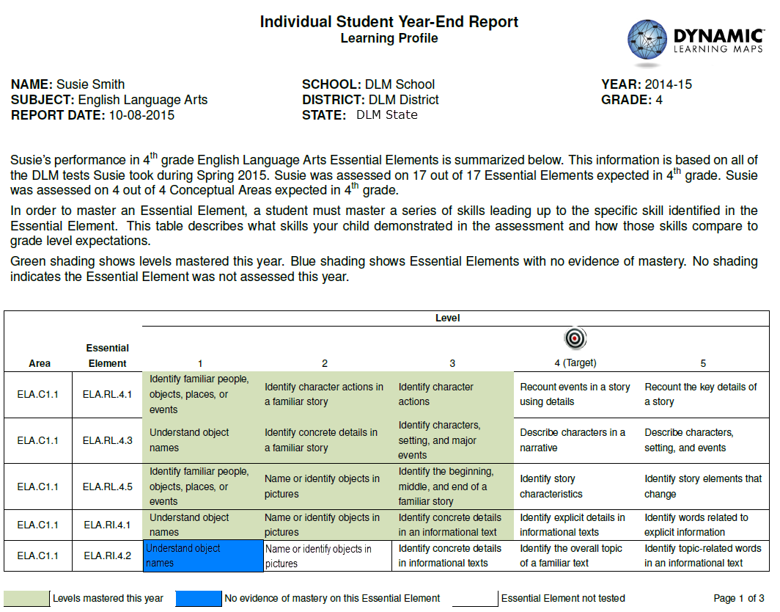

Performance Profile

The Performance Profile provides a report of the student’s performance across Essential Elements from the 2014-2015 blueprints. The number of skills that must be mastered in order to reach a certain performance level was determined at the consortium level (called standard setting) by a group of educators from the consortium states, including content experts and experts in teaching students with the most significant cognitive disabilities. There is no exact correspondence between mastering a particular linkage level on a specific Essential Element and an overall performance level in the subject.

The Performance Profile below shows the student’s mastery of skills for groups of related Essential Elements. The bar graphs show student mastery of skills for claims or conceptual areas.

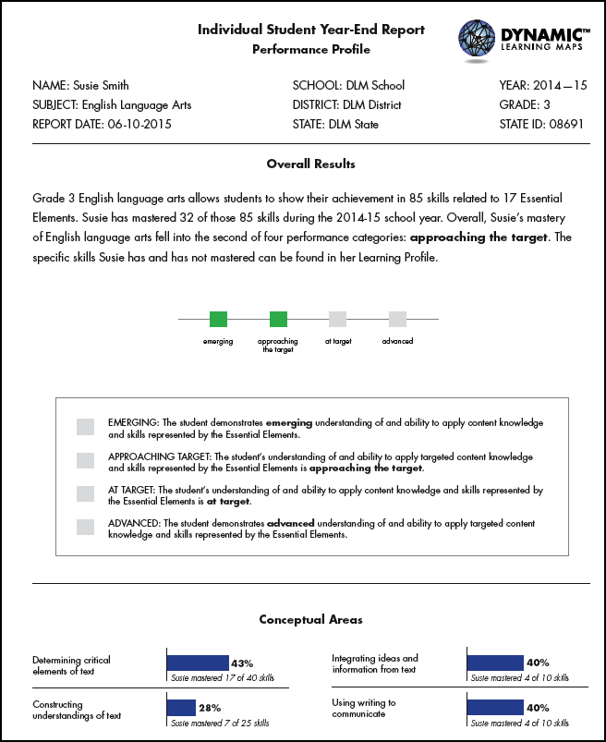

Hints for Interpreting the Learning and Performance Profiles
- Remember that the judgment of mastery is based on what the student demonstrated on the DLM assessments. A student may have demonstrated a similar skill during instruction but not demonstrated the skill during a DLM assessment.
- The assessment measures where students are with regard to the grade-level target. Not all students will perform at the target level, and that is to be expected.
- The number of skills mastered does not mean that a student answered a certain percent of items correctly.
- The amount of white space does not necessarily reflect a lack of instruction. DLM is designed so students may be instructed at a linkage level that is an appropriate level of challenge for them.
- Students with significant cognitive disabilities have a variety of educational goals. Academics are one part of their educational program. Teachers provide instruction beyond what is reflected in the student’s DLM profile, including other academics, functional skills, and other priorities identified in the Individualized Education Program (IEP).

You may use these results to support teachers by:
- helping them consider how the results can be used and the limitations of the data,
- identifying areas of needed professional development to strengthen instruction,
- identifying areas of academic skills where instruction may be focused, and
- reflecting on how a student's overall performance informs the IEP.

Class and School Level Score Results

At the classroom and building levels, the Class Results is a list of individual students with the number of Essential Elements tested, number of linkage levels mastered, and their final performance level.

Each school receives Class Results for every teacher with students who participated in the DLM Alternate Assessment. The students are arranged alphabetically by grade level.

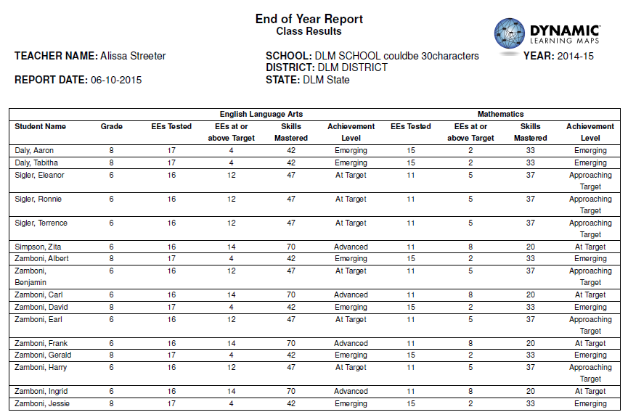

The School Results contain the same information as the Class Results and includes the teacher for each student in the second column. Records for the entire school are organized alphabetically by teacher, and then by grade and student in alphabetical order.

Hints for Interpreting the Class and School Results
- Students appear in the School Results based on the roster and school where they were assessed. This may not be the same school where they are counted for accountability purposes.
- If a student was on more than one roster, the student appears once for each roster (one column for ELA and one column for math).
- If a student was enrolled in DLM assessments but did not complete any portion of the assessment, the student is not counted in these results. [By subject. Represented by ‘-‘ in school and class roster.]
- Remember that the judgment of skill mastery is based on what the student demonstrated on the Dynamic Learning Maps assessments. A student may have demonstrated a similar skill during instruction but not demonstrated the skill during a DLM assessment.
- The assessment measures where students are with regard to the grade-level target. Not all students perform at the target level, and that is to be expected.
- These results only provide a summary of overall performance in the grade/subject. More useful information for instructional planning is located in each student’s Learning Profile.

District and State Level Results

The Final District Results provides one table for each subject: one for English language arts and one for mathematics. Each table contains a row that shows the number of students tested at each grade level and the number of those who were at each performance level in the subject. The last column indicates percent of students at the Target or Advanced levels.

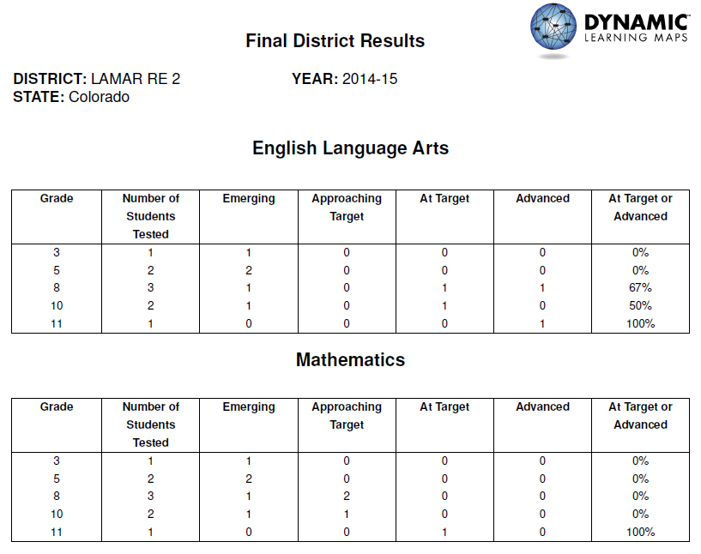

The Final State Results has the same formatting and provides the same type of information for all student records in the state.

Hints for Interpreting Final District and State Results
- Student results are reported for the district where they were assessed (the Attendance). This may not be the same district where they are counted for accountability purposes.
- If a student was enrolled in more than one district, the student appears once in each Final District Results and counted twice in Final State Results.
- If a student was enrolled in DLM assessments but did not complete any portion of the assessment, the student is not counted in these results. [Student who did not provide any responses]
- Both of these results provide a high-level summary of students at the district or state level. More useful information for instructional planning is located in each student’s Learning Profile.
- The assessment measures where students are with regard to the grade-level target. Not all students perform at the target level, and that is to be expected.

How Reports Are Distributed
Student score reports are generated as separate PDF files. There is one PDF per student per subject. Individual student score reports are packaged for delivery in folders, organized by district name, school name, and grade.

Other - NJ (DOE added)

Reports will be delivered electronically by DLM via secure download. DLM will notify District Test Coordinator and District Data Steward for the DLM before delivery.

Types of Aggregated Reports
• Classroom and school-level reports
• District-level reports
• State-level report

At the classroom and school levels, roster reports list individual students with the number of Essential Elements tested, number of linkage levels mastered, and final performance level.

District- and state-level reports provide frequency distributions, by grade level and overall, of students tested and achieving at each performance level in English language arts and mathematics.

Students who were enrolled in Educator Portal but did not complete any of the assessment are excluded from aggregated reports. (not-tested: e.g. parental refusal to take tests, or other reason)

For students who did not test in a content area, the classroom and school roster reports include a row for that student, with an indication (“-“) that the student did not test in the content area. The district and state reports do not include students who did not test in a content area in the frequency counts.

